BeNutritious

Design Document

**Submitted For:**

SER515 – Software Enterprise: Inception and Elaboration.

Arizona State University

**Submitted By:**

Akash Chugh

ASU ID: 1211165446

Email: Akash.Chugh@asu.edu

Contents

1. Class Diagram: 3

2. Component Diagram: 4

3. Activity Diagram: 5

4. Sequence Diagram: 6

5. Use Case: 7

6. State Diagram: 8

# Class Diagram:

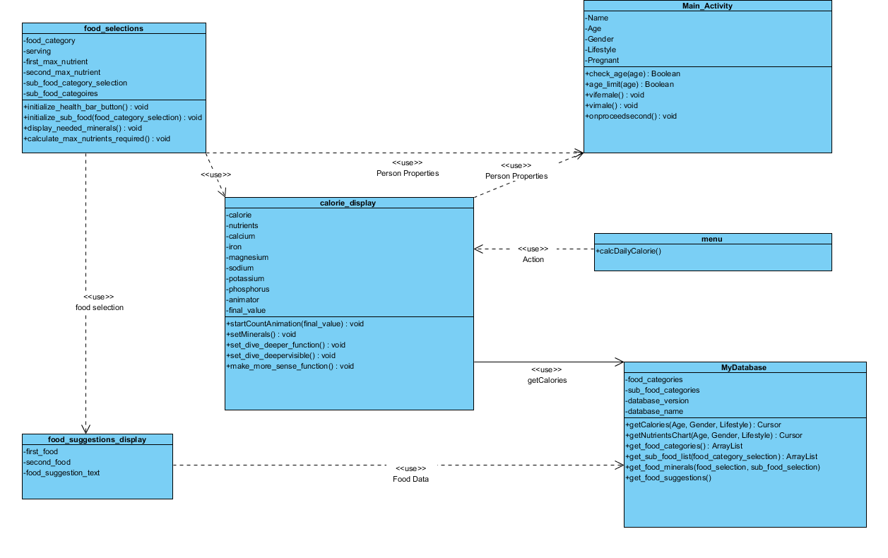

# Component Diagram:

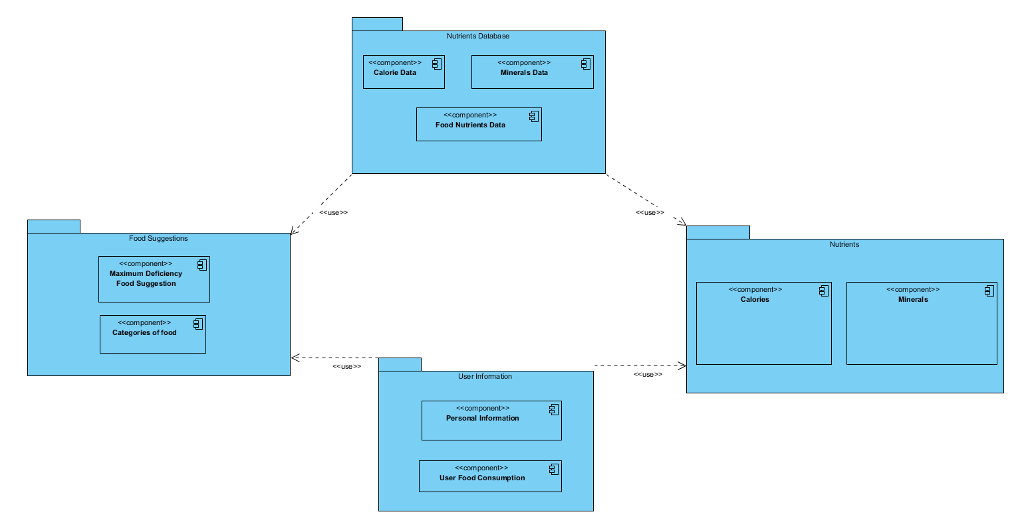

# Activity Diagram:

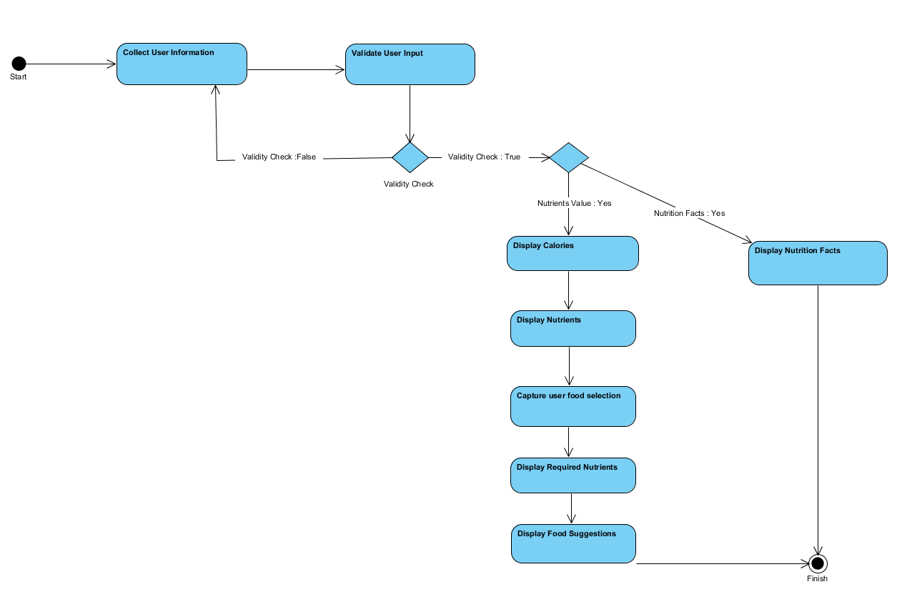

# Sequence Diagram:

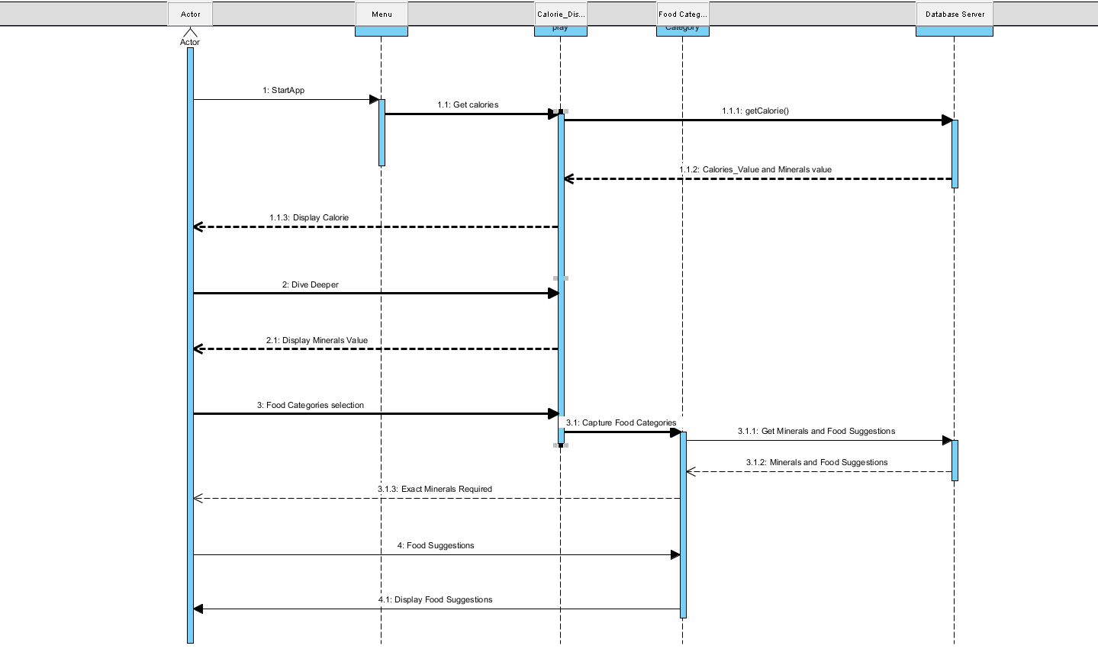

# Use Case:

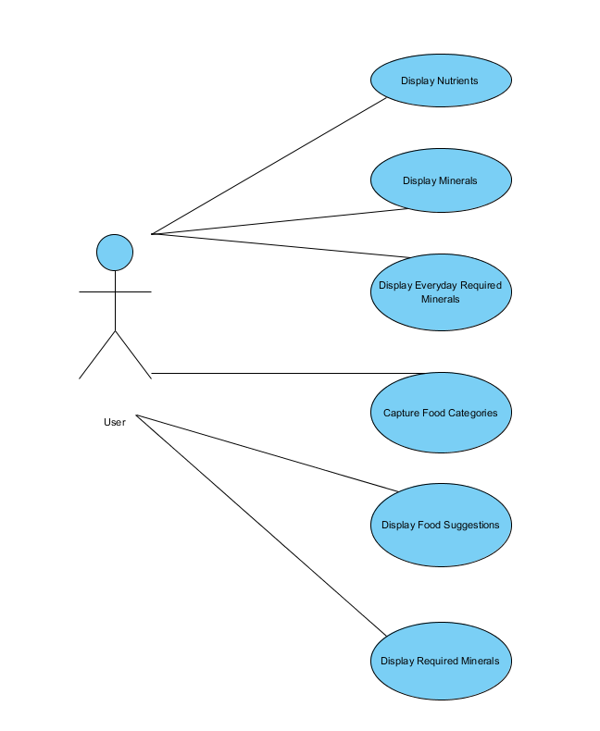

# 6. State Diagram: